Variables

Batch size = 19

Seq_len = 6/3

Pre_len = 1

History days = 6

Grid sizes = [4,4], [4]

Train size = 36

test -size = 6+6

Testing on 7 Dec

1 day -> 6 windows for 3 hr each (6am-12 midnight)

6 days training data -> 6*6 =36 windows

Train point -> 6 windows -> predict one

30 training points

**Autocorrelation with lag -> motivates seq_len=6**

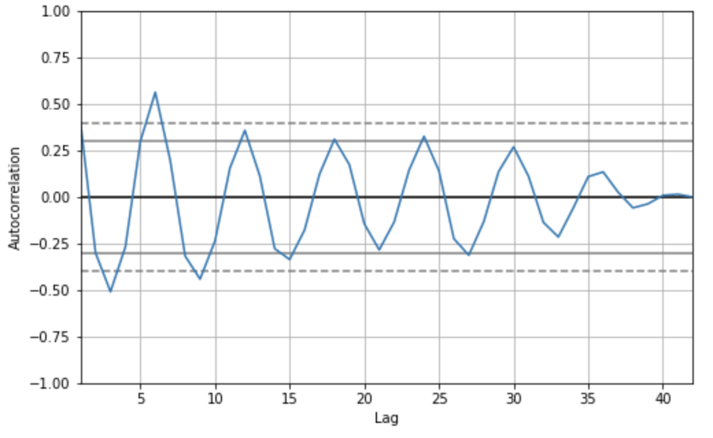

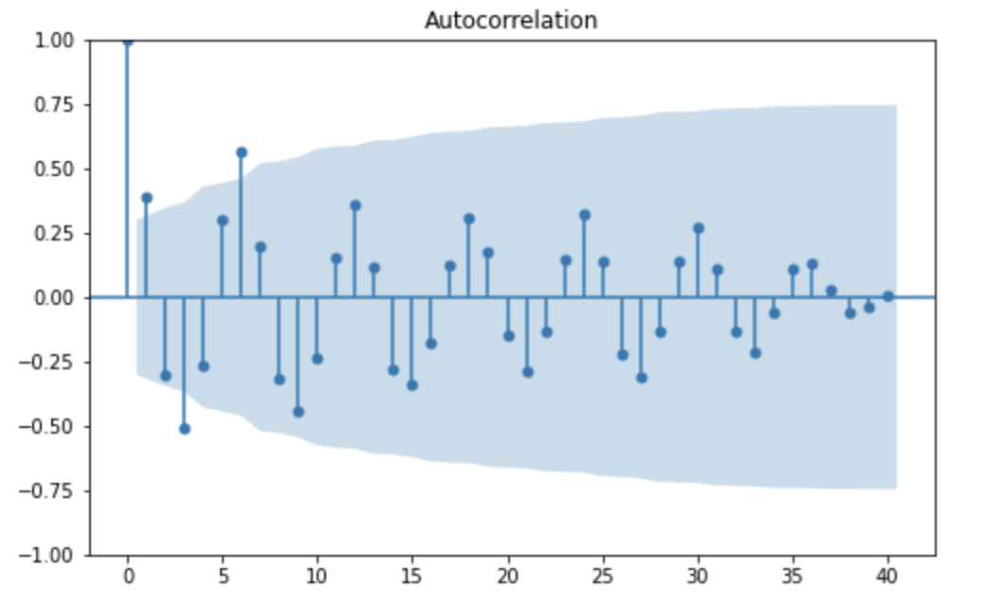

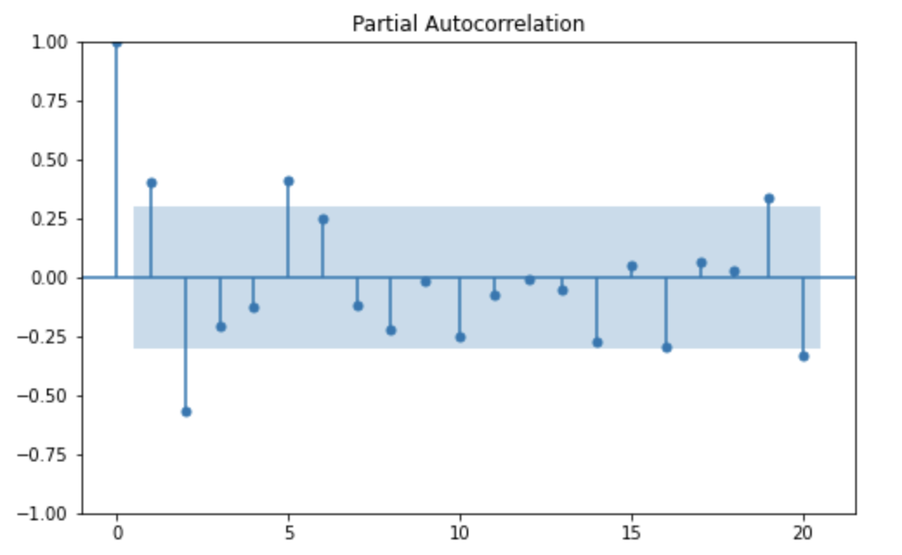

**RMSE trend with Pollution distribution**

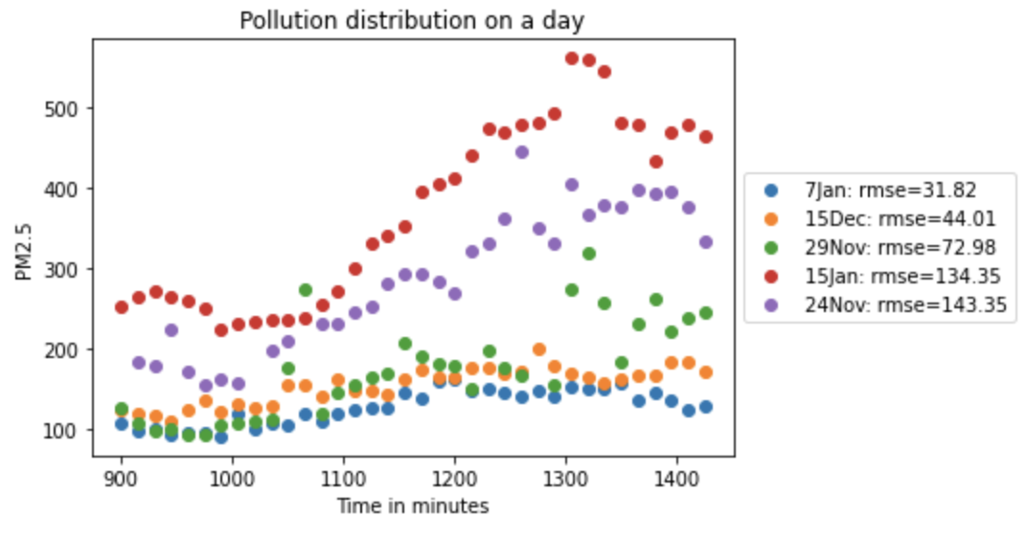

**Model Architecture**

**(krithika can fill the table)**

|  | index | Mean Train loss | Last Train loss | Mean Test loss | Last Test loss | Train time (secs) | GCN sizes | LSTM sizes | History (in days) |
| --- | --- | --- | --- | --- | --- | --- | --- | --- | --- |
| 0 | 38.5 | 94.2580688525 | 66.48720005875000 | 64.69458354125000 | 49.090171395 | 3.9830318101250000 | [4, 4] | [4] | 6 |
| 8 | 46.5 | 70.6151275 | 50.26716571125 | 59.287923918750000 | 52.545134125000000 | 3.6991605666250000 | [4, 4] | [32] | 6 |
| 7 | 45.5 | 78.97841891500000 | 62.47743018750000 | 60.123056247500000 | 52.893180011250000 | 3.822458997 | [4, 4] | [16] | 6 |
| 6 | 44.5 | 84.938281615 | 61.73052775875 | 61.28913302375 | 53.3066537775 | 3.7548767528750000 | [4, 4] | [8] | 6 |
| 1 | 39.5 | 96.53398816500000 | 73.18217939500000 | 66.113660815 | 54.34237668375000 | 3.796521518625 | [8, 8] | [4] | 6 |
| 3 | 41.5 | 95.74772663625 | 71.6254579025 | 67.97168732625 | 55.04870339125 | 3.9544698480000000 | [32, 32] | [4] | 6 |
| 5 | 43.5 | 96.258066565 | 71.5258896275 | 66.63109829625 | 55.46911929750000 | 4.085093440500000 | [4, 8, 16] | [4] | 6 |
| 2 | 40.5 | 94.48737495375000 | 71.36494214875000 | 67.66307173375 | 55.62223859375 | 3.8207369168750000 | [16, 16] | [4] | 6 |
| 4 | 42.5 | 97.95957968125 | 76.33775673625 | 68.35347885250000 | 57.60612561750000 | 3.9454270898750000 | [4, 4, 4] | [4] | 6 |
| 9 | 47.5 | 99.733313775 | 76.9956960825 | 70.9515581 | 59.31562862625 | 5.126682557000000 | [4, 4] | [4, 4] | 6 |
| 10 | 48.5 | 93.35846271875 | 74.11729608625 | 68.63853918 | 65.18454072250000 | 5.0689431635 | [4, 4] | [4, 8] | 6 |

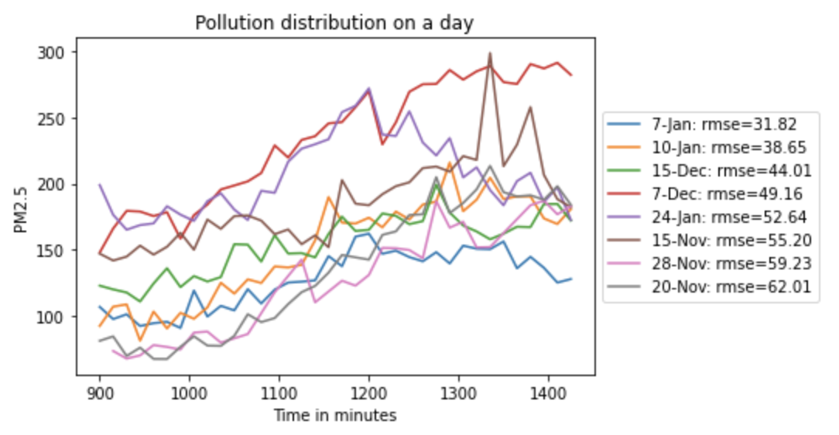

History(number of days for training)

**Fine-tune vs scratch**

|  | **Mean Train loss** | **Last Train loss** | **Mean Test loss** | **Last Test loss** | **Train time callbacks** | **GCN sizes** | **LSTM sizes** | **History (in days)** | **Test Date** |
| --- | --- | --- | --- | --- | --- | --- | --- | --- | --- |
| **0** | 61.805040675650000 | 52.34558063248790 | 57.3731951713562 | 49.15956810116770 | 3.7113008585292800 | [4, 4] | [4] | 6 | 7 Dec |
| **0** | 56.01865477388100 | 47.10285837451620 | 76.55316038131710 | 70.17920158803460 | 4.17643123306334 | [4, 4] | [4] | 6 | 8 Dec |
| **0** | 54.87529041953390 | 50.46077057719230 | 78.70011374155680 | 65.32647411028540 | 3.792403106112030 | [4, 4] | [4] | 6 | 9 Dec |
| **0** | 57.14359455108640 | 45.76377289990580 | 118.58719546000200 | 116.26418982942900 | 3.61004425981082 | [4, 4] | [4] | 6 | 10 Dec |
| **0** | 74.4335310695072 | 64.06515568494800 | 71.14181137084960 | 62.35751457512380 | 4.13276413269341 | [4, 4] | [4] | 6 | 11 Dec |
| **0** | 83.57251023257400 | 75.73648235801120 | 67.6509439950404 | 67.37798307981830 | 3.6427000360563400 | [4, 4] | [4] | 6 | 12 Dec |
| **0** | 82.48065233815710 | 72.06229340528020 | 110.90170465655900 | 100.47176315165700 | 3.5903436252847300 | [4, 4] | [4] | 6 | 13 Dec |
| **0** | 88.95042856121840 | 73.83445952452070 | 104.47550756931300 | 75.38884755709900 | 3.5528459183406100 | [4, 4] | [4] | 6 | 14 Dec |

Fine-tune 0.004

|  | **Mean Train loss** | **Last Train loss** | **Mean Test loss** | **Last Test loss** | **Train time callbacks** | **lr** | **Test Date** |
| --- | --- | --- | --- | --- | --- | --- | --- |
| **0** | 61.805040675650000 | 52.34558063248790 | 57.3731951713562 | 49.15956810116770 | 5.800706290407110 | 0.01 | 7 Dec |
| **0** | 46.706744142125000 | 46.40826823810740 | 61.61511720021570 | 59.7058367729187 | 3.7790785506367700 | 0.01 | 8 Dec |
| **0** | 45.5323380878816 | 49.830625082055700 | 67.75606174468990 | 70.5789374311765 | 3.6050739826168900 | 0.01 | 9 Dec |
| **0** | 47.30215227790180 | 44.53288123011590 | 106.13705908457400 | 109.78963653246600 | 3.591836852254350 | 0.01 | 10 Dec |
| **0** | 55.03590907404820 | 52.43555458883440 | 74.14670314788820 | 73.00248061617220 | 3.7482179917860800 | 0.01 | 11 Dec |
| **0** | 54.117877084753800 | 56.13180187814260 | 77.30299286738690 | 69.72541332082910 | 3.63104046555236 | 0.01 | 12 Dec |
| **0** | 51.548858099710200 | 49.15164892440260 | 83.91571509008820 | 83.13903439911490 | 3.6655115061439600 | 0.01 | 13 Dec |
| **0** | 53.07360355942710 | 53.48211067202300 | 40.94048778622050 | 39.462893771858 | 3.8610075840260800 | 0.01 | 14 Dec |

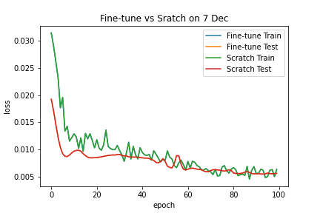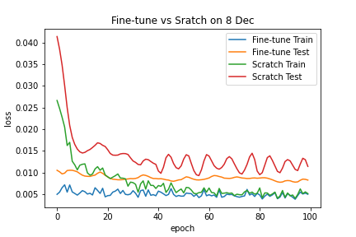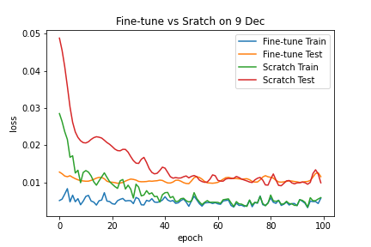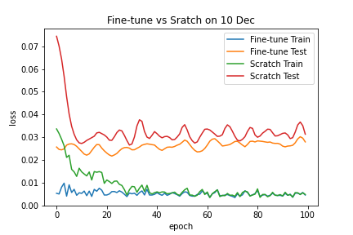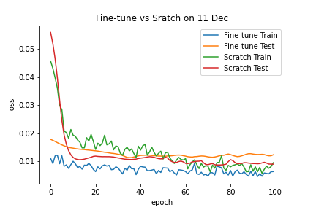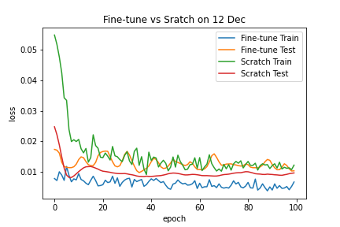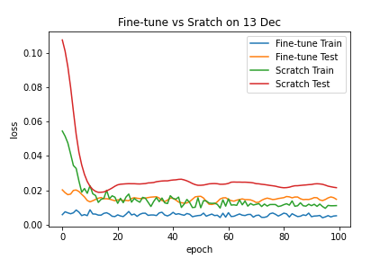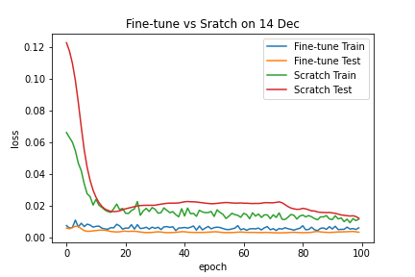

Fine-tune lr =0.004 on 7Jan (experiment in case)

|  | **Mean Train loss** | **Last Train loss** | **Mean Test loss** | **Last Test loss** | **Train time callbacks** | **Test Date** |
| --- | --- | --- | --- | --- | --- | --- |
| **0** | 104.3063002 | 58.43914718 | 66.98791219 | 31.81635097 | 5.803637017 | 7-Jan |
| **0** | 47.86997384 | 43.7330543 | 46.82242653 | 47.09219623 | 3.669972739 | 8-Jan |
| **0** | 39.63133103 | 35.95465551 | 48.88952719 | 46.28504547 | 3.547181892 | 9-Jan |
| **0** | 72.65847301 | 48.78880178 | 41.40105315 | 45.47118176 | 3.584514135 | 10-Jan |
| **0** | 45.75457518 | 38.21110189 | 47.48572555 | 49.13673463 | 3.724126115 | 11-Jan |

**Baselines**

| **Day** | **GCN-LSTM** | **Nbeats** | **Arima** |
| --- | --- | --- | --- |
| 7-Jan | 31.8163539 | 34.5628266827153 | 51.7144371729439 |
| 10-Jan | 38.6459524 | 51.0024335764057 | 48.7195291216627 |
| 15-Dec | 44.01426855 | 59.2445606673397 | 68.0440021185526 |
| 7-Dec | 49.1595681 | 44.5102823816759 | 119.986115844228 |
| 24-Jan | 52.63929705 | 70.6995655036885 | 73.509900431794 |
| 15-Nov | 55.20377323 | 157.184154870181 | 114.707544411476 |
| 28-Nov | 59.22861949 | 64.6453399541218 | 78.4150493987065 |
| 20-Nov | 62.01353844 | 62.1173810688567 | 101.588690009238 |
| Average | 49.090171395 | 67.995818088123 | 82.0856585635751 |